**NAME:** Savan Yeshwanth Rao

**CSUID:** 2784780

**LAB- DHCP Report**

* Screen shots of Command prompt window:

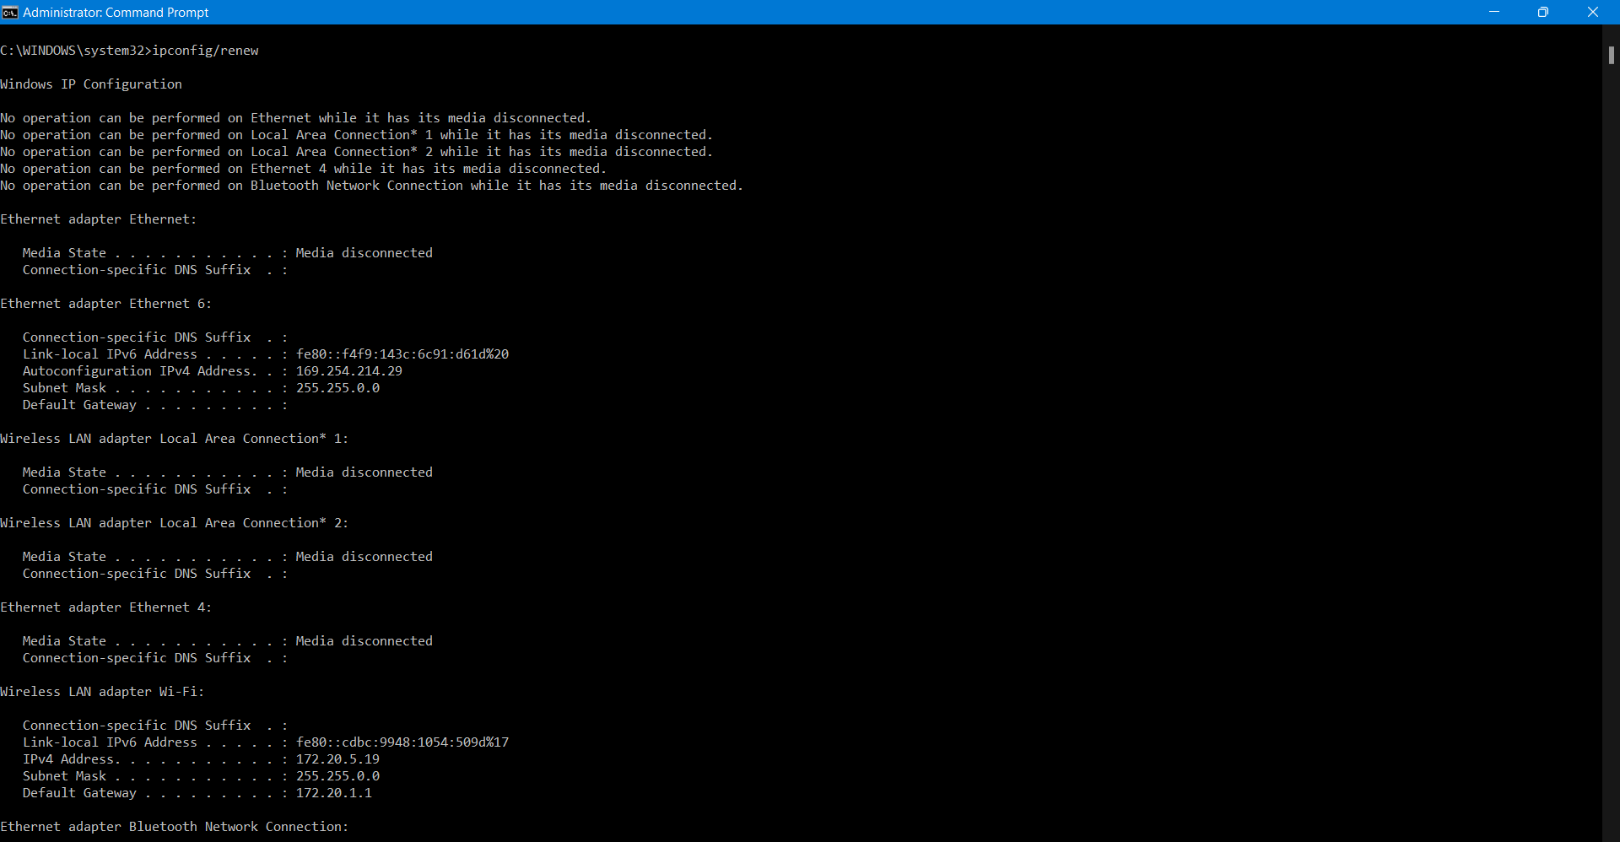

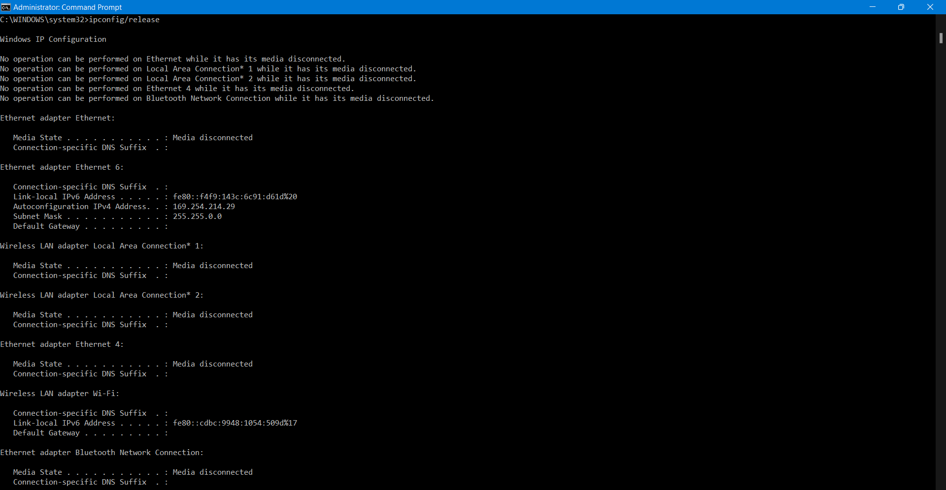

1. The DHCP message was sent over **UDP**.

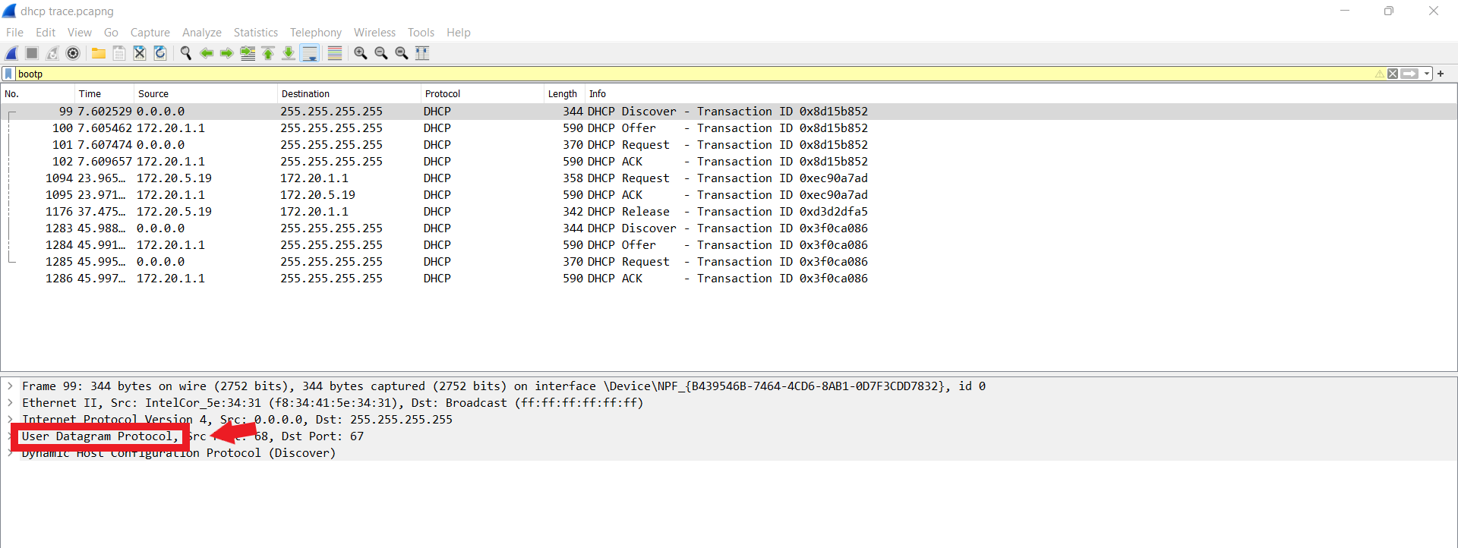

1. Yes, the port number is same as the example given in the lab assignment.

The Discover packet has a source port of 68 and destination port of 67,  
The Offer packet has a source port of 67 and a destination port of 68,  
The Request packet has a source port of 68 and a destination of 67,  
The ACK packet has a source port of 67 and a destination of 68.

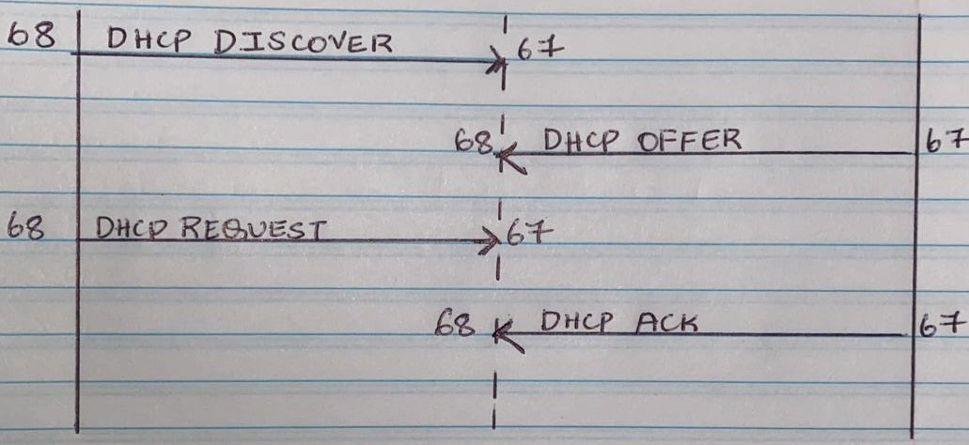

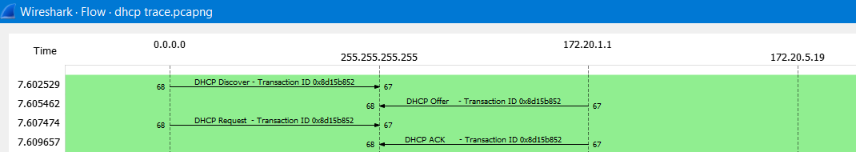

1. The link-layer address of my host is: IntelCor_5e:34:31 i.e., **f8:34:41:5e:34:31**

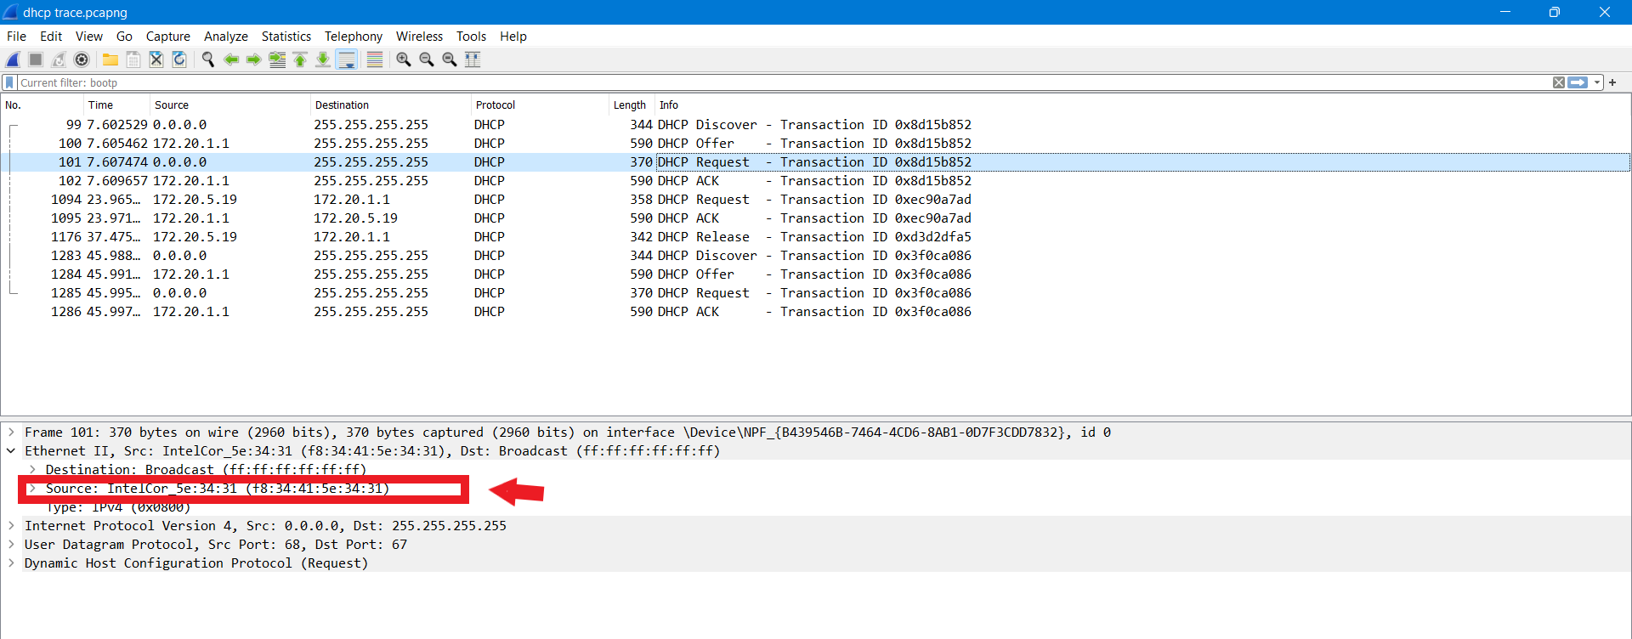

1. The values which differentiate the discover message from the request message are in **Option 53** which indicates: **DHCP message type**

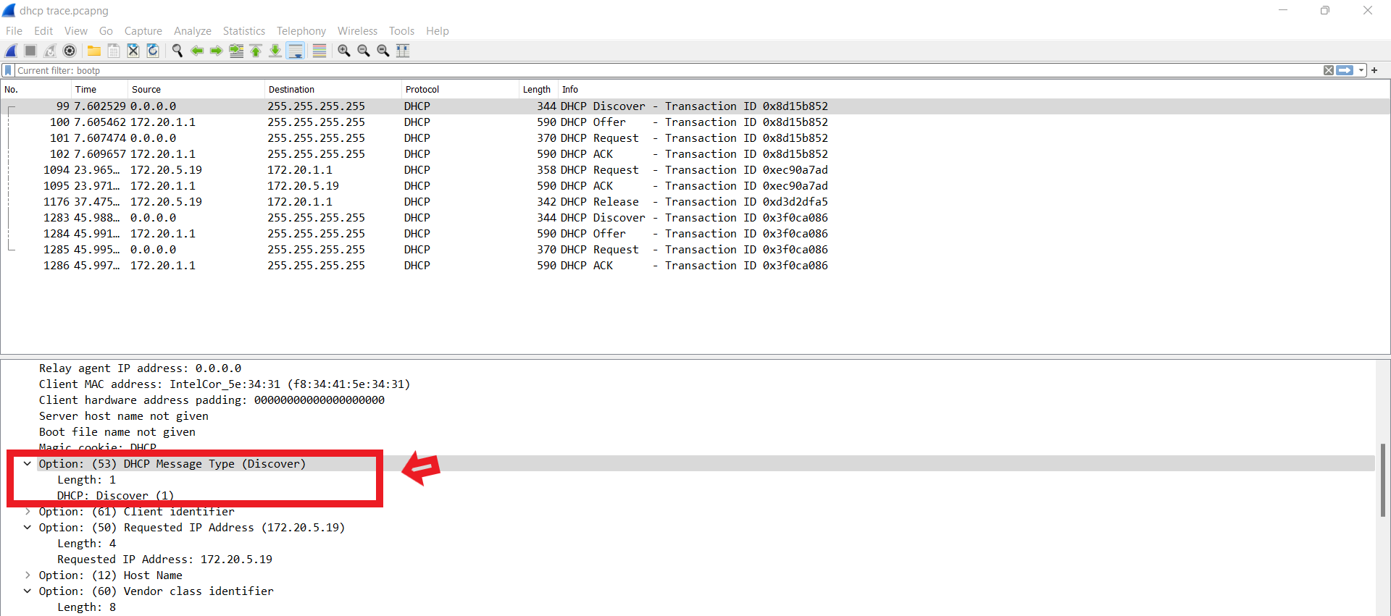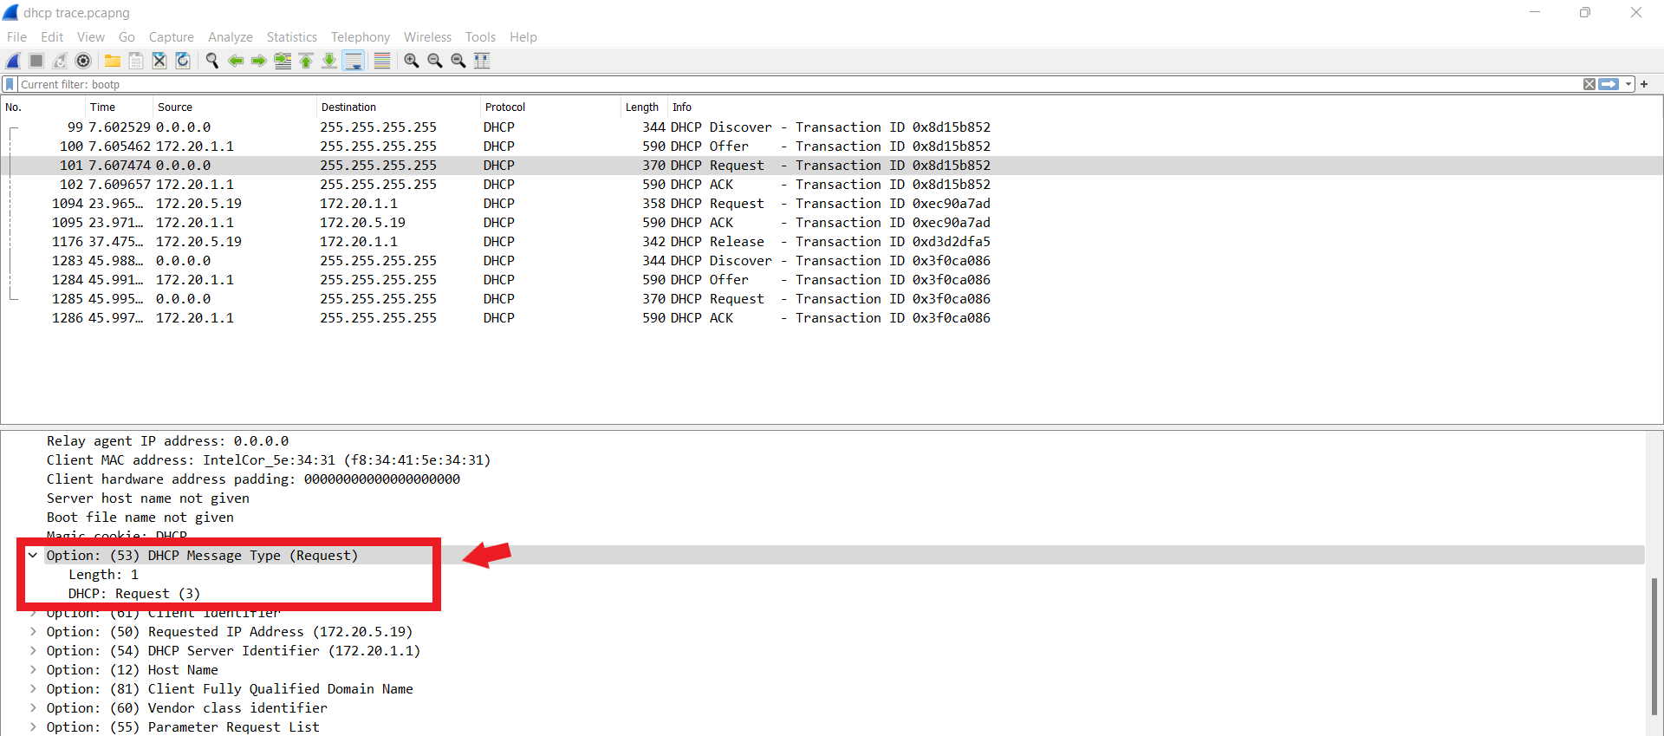

1. The first 4 DHCP message and its value of transaction-ID is:

Transaction-ID for Discover – 0x8d15b852

Transaction-ID for Offer – 0x8d15b852

Transaction-ID for Request – 0x8d15b852

Transaction-ID for ACK – 0x8d15b852.

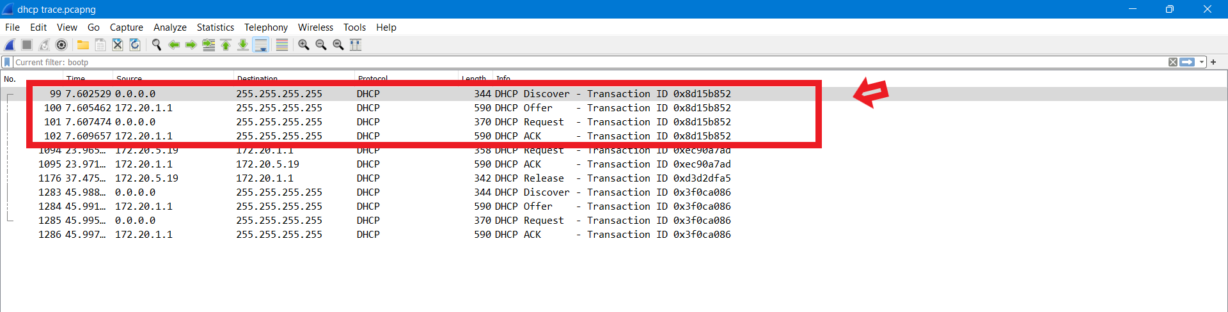

For 2nd set

Transaction-ID for request – 0xec90a7ad

Transaction-ID for ACK – 0xec90a7ad

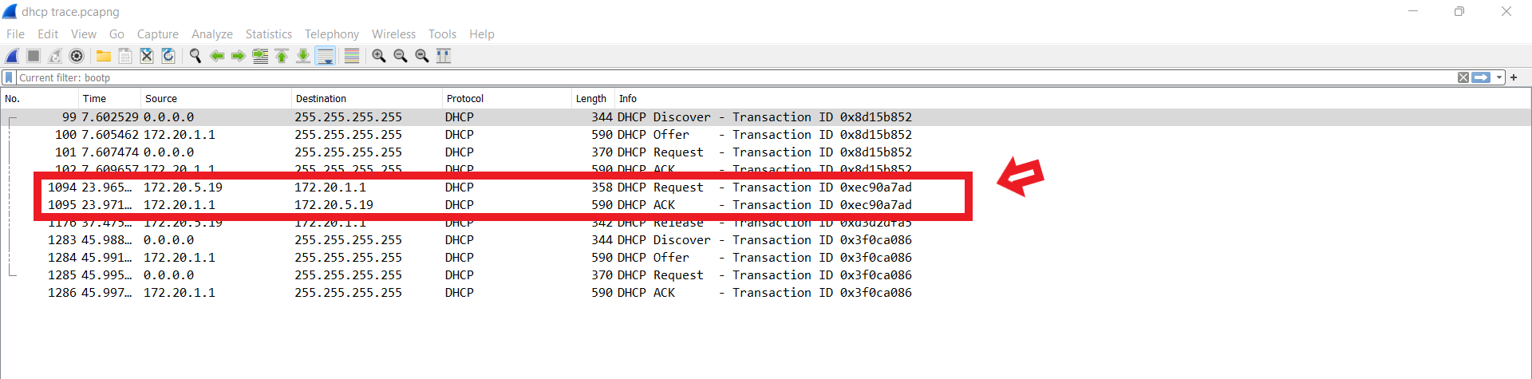

The Transaction-ID is used so that a DHCP server can give the difference between client requests during the request process.

1. When the IP is not set the DHCP server and client both uses 255.255.255.255 as the destination IP address. The client uses source IP address as 0.0.0.0, where as the server uses its original IP address as the source IP address (172.20.1.1).

In Our lab the source and destination address of 1st four DHCP messages are:

For Discover: source address-0.0.0.0 and destination address-255.255.255.255

For Offer: source address- 172.20.1.1 and destination address 255.255.255.255

For Request: source address-0.0.0.0 and destination address-255.255.255.255

For ACK: source address- 172.20.1.1 and destination address 255.255.255.255



1. The IP address of DHCP server is**: 172.20.1.1**

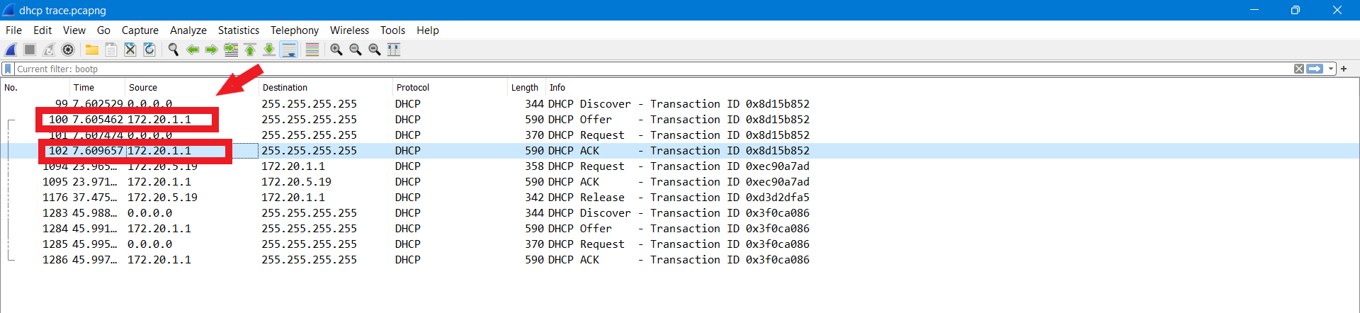

1. The IP address- **172.20.5.19** is the DHCP server offering to my host in the DHCP Offer message.

As we can see from the below expanded DHCP protocol screenshot of DHCP Offer, the field “Your (Client) IP address” is the offered DHCP address.

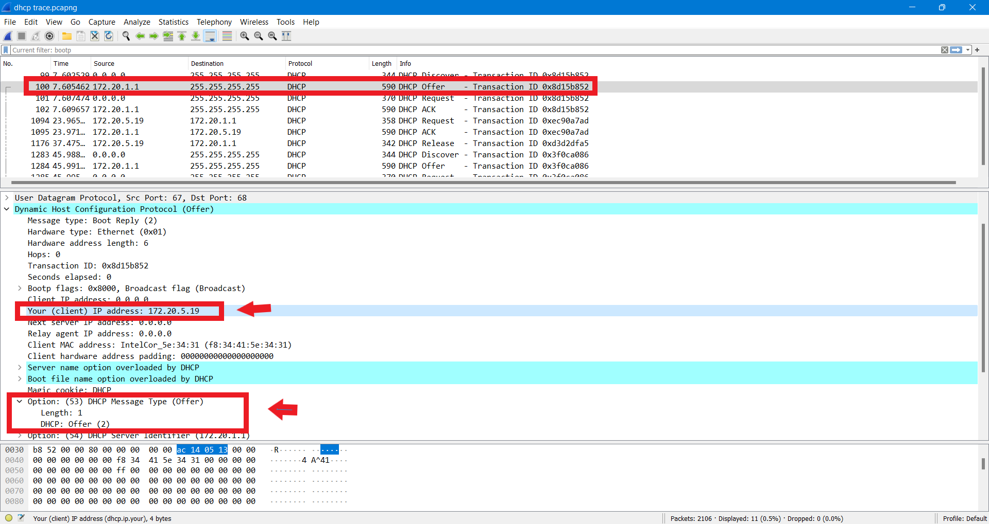

1. From the Screen shot below we can see that the field “Relay agent IP address” - 0.0.0.0, which tells us that there is no DHCP Relay used. There is no Relay Agent used in this example.

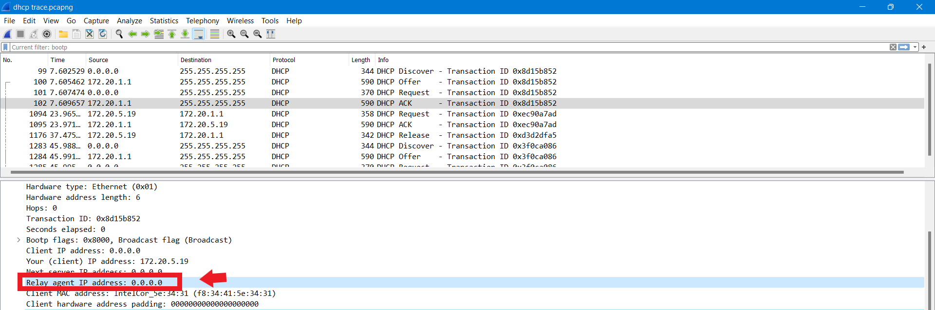

1. The Router field is Option (3) and the Subnet Field is Option (1) which are show below in the screen shot.

The routers IP address- 172.20.1.1 indicates the client what its default gateway should be used.

The Subnet Mask address- 255.255.255.0 indicates the client what subnet mask should be used.

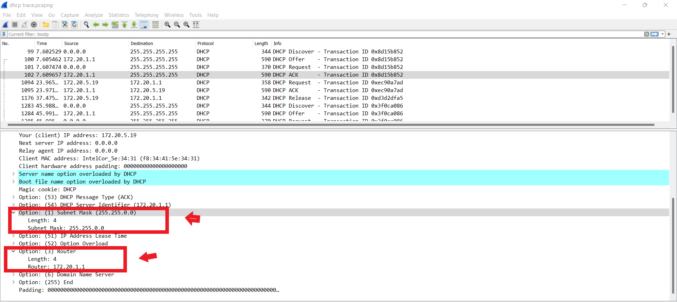

1. The same thing occurs here as that to solution 8, the host requests the offered IP address in the DHCP request message. We can see from the below screen shot a field “requested IP Address”.

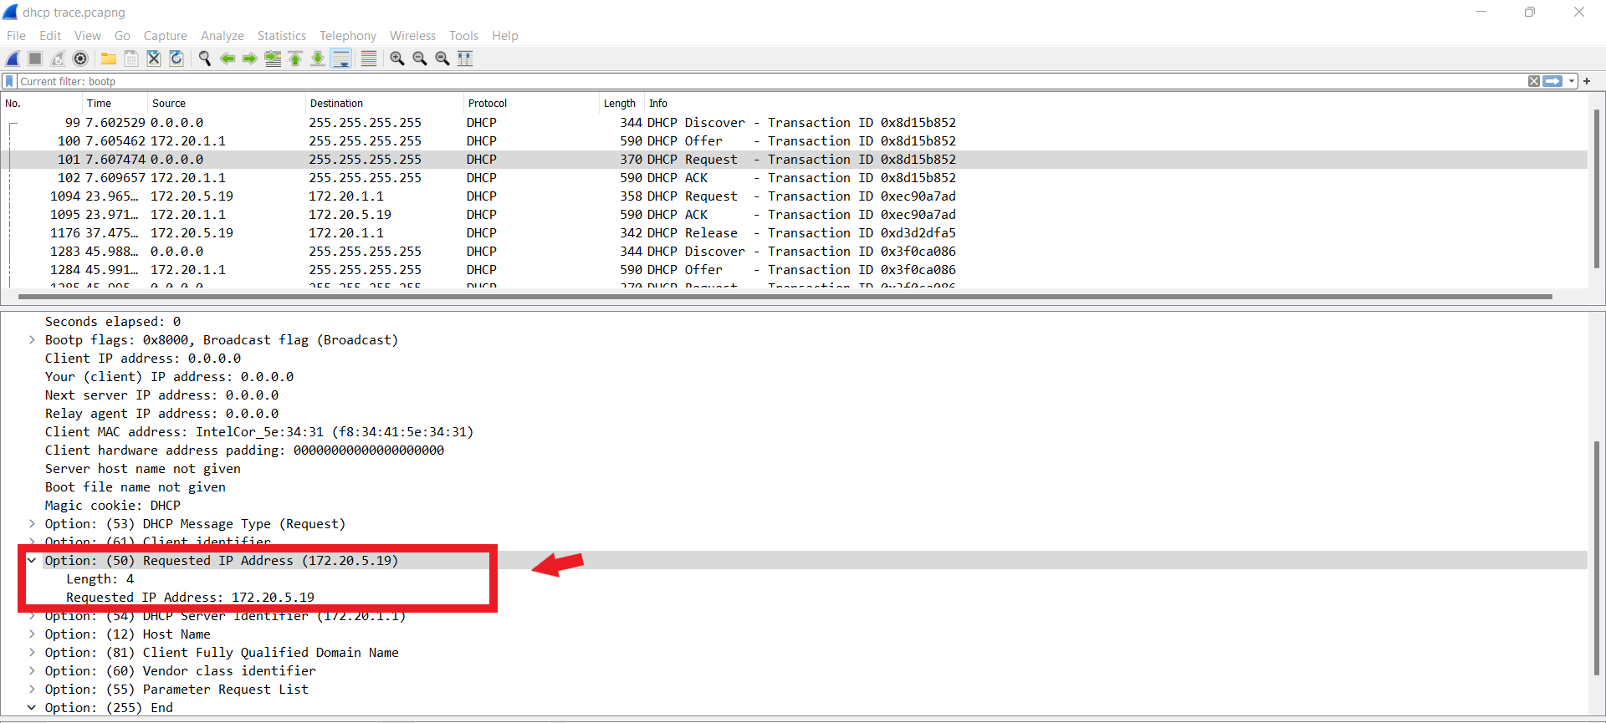

* The Lease Time is defined as the amount of time the DHCP server assigns or offers an IP address to a client. During this time the offered IP address is not given to any other client until its allocated time, until and unless it is released manually by the client using the command in CMD ipconfig/release (for windows). Once the lease time is ended then it can be reused by the DHCP server to give it to another client.
* In my experiment The Lease time is 84600 seconds which is 1 day.

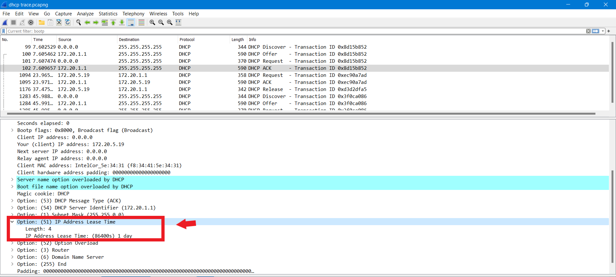

* The purpose of DHCP release message is when the client sends a DHCP release command it removes the offered IP address by the DHCP server before the lease time ends.
* The DHCP server does not send or issue any message back to the client acknowledging the DHCP release message.
* If the client’s DHCP release message is lost, in this situation the DHCP server would wait until the lease period is over for that offered address and then it could be reused for another client.

1. Yes, as you can see from the screen shot below there are ARP requests made By the DHCP server. The DHCP server issues an ARP request to check whether the IP address that is being offered by DHCP server is not already being used by any other workstation.

